**ASSIGNMENT-3**

**CLOUD OBJECT STORAGE AND WATSON ASSISTANT**

|  |  |
| --- | --- |
| **ASSIGNMENT DATE** | **17 OCTOBER 2022** |
| **STUDENT NAME** | **RENISHA A** |
| **STUDENT ROLL NO** | **9517201903121** |
| **MAXIMUM MARKS** | **2 Marks** |

**Question1 Create a bucket in IBM storage**

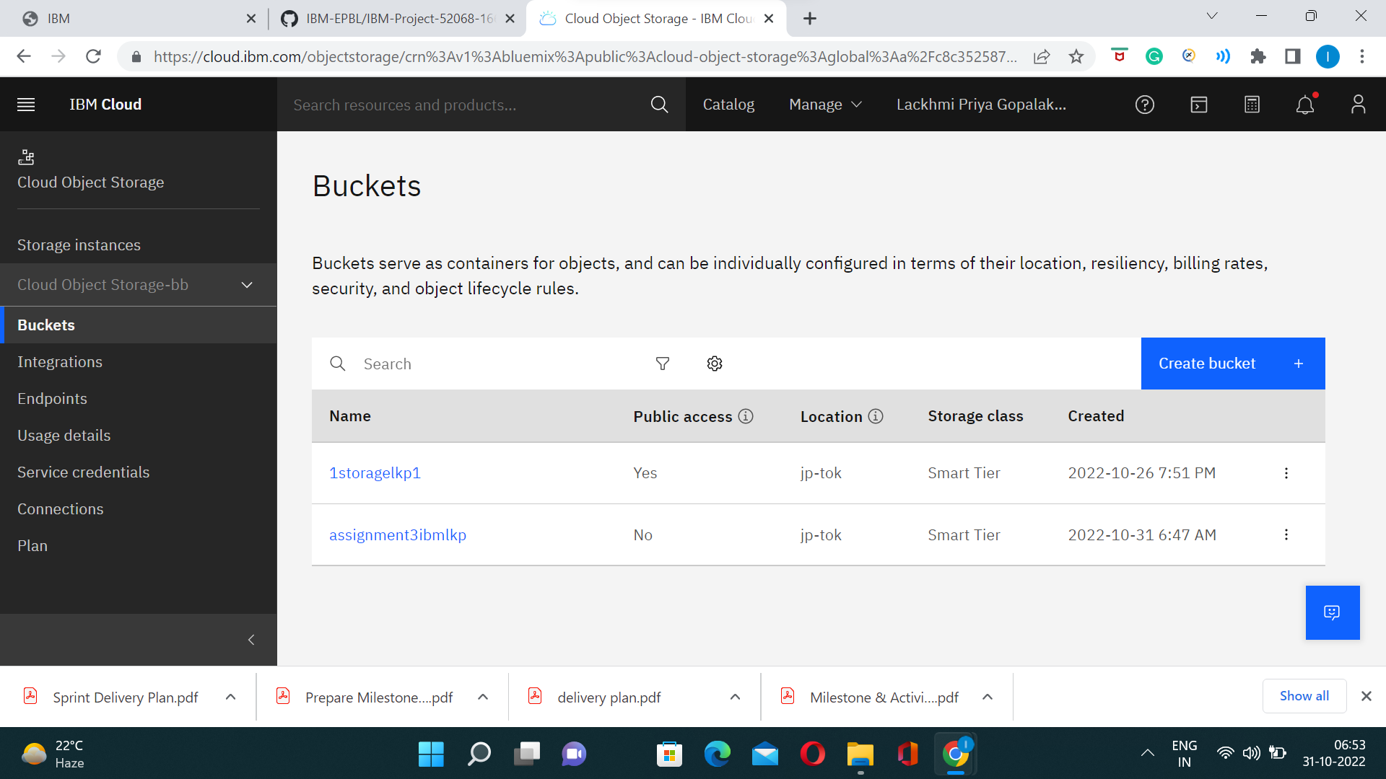

**QUESTION 2 .Upload 5 images to ibm object storage and make it public. write html code to displaying all the 5 images.**

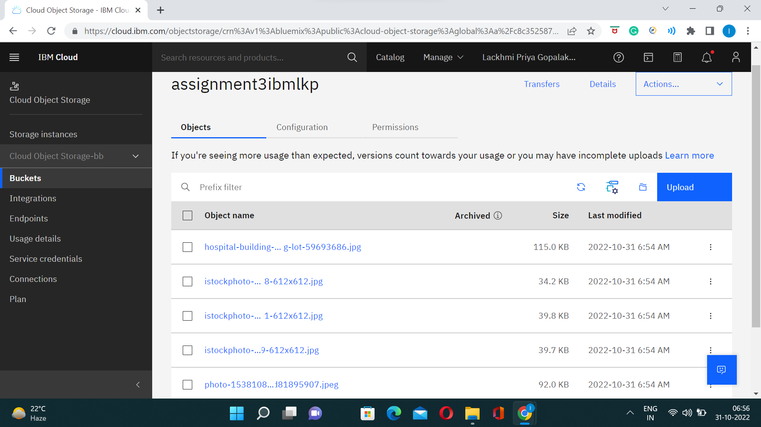

**<!DOCTYPE html>**

**<html lang="en">**

**<head>**

**<meta charset="UTF-8">**

**<meta http-equiv="X-UA-Compatible" content="IE=edge">**

**<meta name="viewport" content="width=device-width, initial-scale=1.0">**

**<link rel="stylesheet" href="https://s3.jp-tok.cloud-object-storage.appdomain.cloud/assignment3ibmlkp/styles3.css">**

**<title>Object storage</title>**

**</head>**

**<body>**

**<h3>Images are displayed from object storage</h3>**

**<div class="grid-container">**

**<div class="item">**

**<img src="https://s3.jp-tok.cloud-object-storage.appdomain.cloud/assignment3ibmlkp/hospital-building-modern-parking-lot-59693686.jpg">**

**</div>**

**<div class="item">**

**<img src="https://s3.jp-tok.cloud-object-storage.appdomain.cloud/assignment3ibmlkp/istockphoto-1179324818-612x612.jpg">**

**</div>**

**<div class="item">**

**<img src="https://s3.jp-tok.cloud-object-storage.appdomain.cloud/assignment3ibmlkp/istockphoto-1295301481-612x612.jpg">**

**</div>**

**<div class="item">**

**<img src="https://s3.jp-tok.cloud-object-storage.appdomain.cloud/assignment3ibmlkp/istockphoto-482858629-612x612.jpg">**

**</div>**

**<div class="item">**

**<img src="https://s3.jp-tok.cloud-object-storage.appdomain.cloud/assignment3ibmlkp/photo-1538108149393-fbbd81895907.jpeg">**

**</div>**

**</div>**

**</body>**

**</html>**

**Question 3:-Upload a CSS page to the object storage and use the same page in your HTML code.**

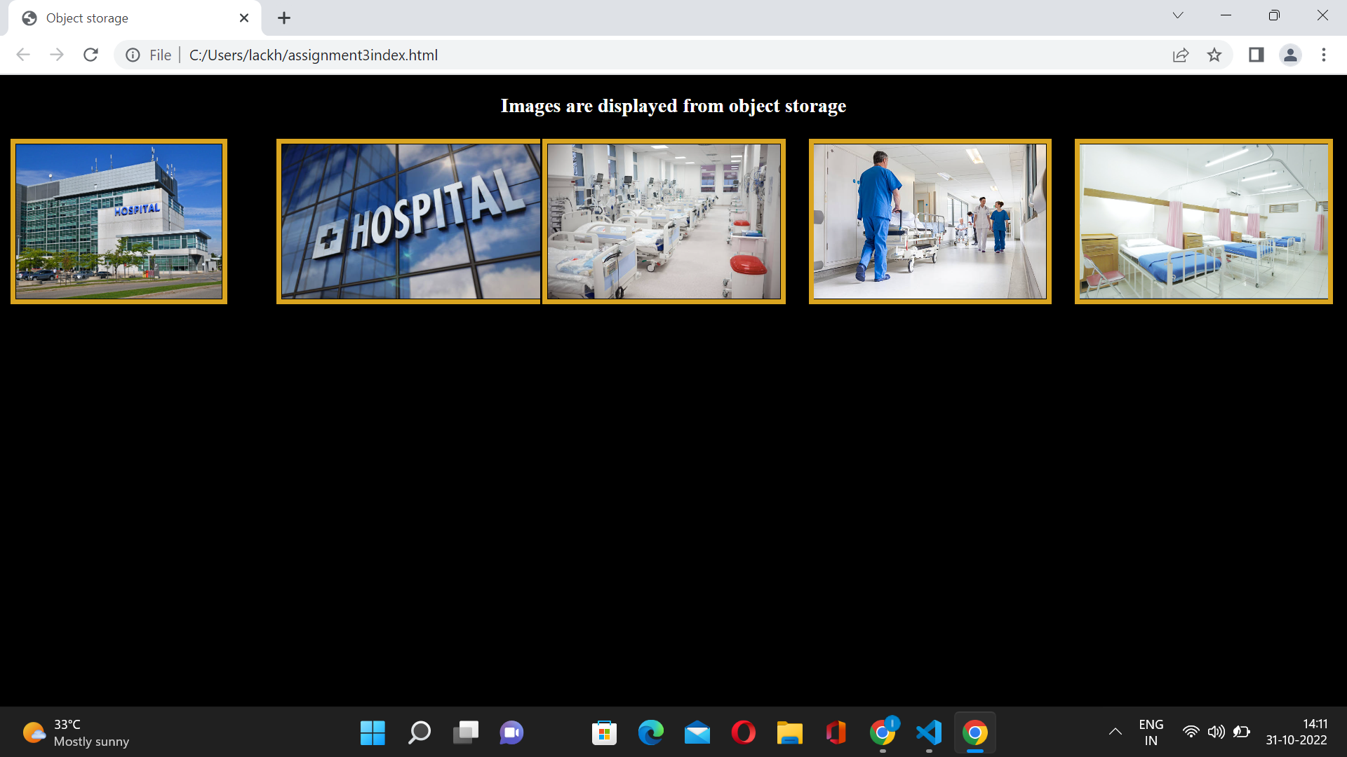

**Question 4:-**

**4.Design a chatbot using IBM Watson assistant for hospital. Ex: User comes with query to know the branches for that hospital in your city. Submit the web URL of that chat bot as an assignment.**

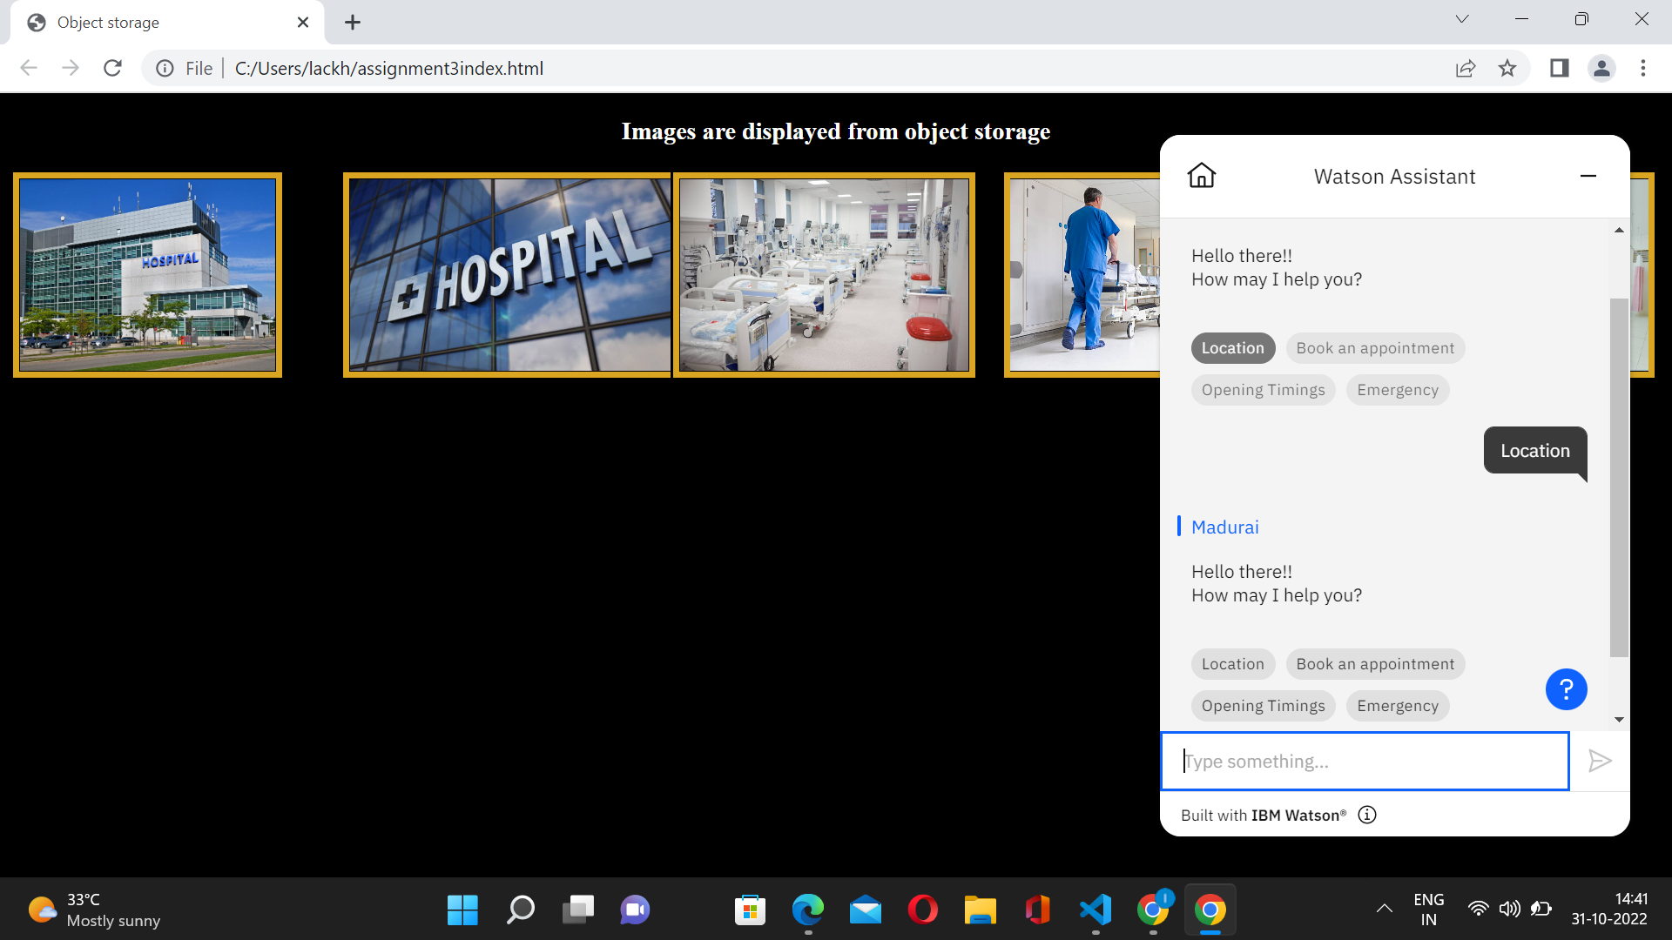

**Question 5**

**5.Create Watson assistant service with 10 steps and use 3 conditions in it. Load that script in HTML page.**

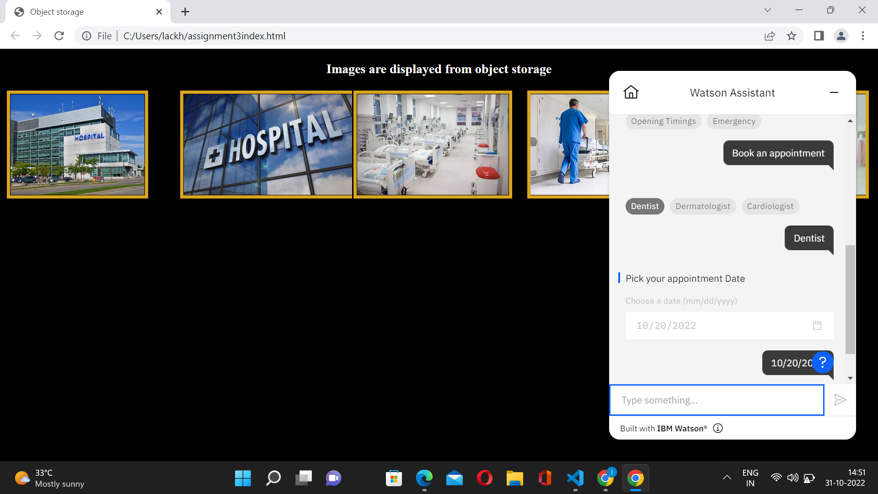

**<script>**

**window.watsonAssistantChatOptions = {**

**integrationID: "0bcf5e03-b672-41cc-ad8b-a650985b73b4", // The ID of this integration.**

**region: "us-south", // The region your integration is hosted in.**

**serviceInstanceID: "11e2a137-3b9a-469a-bfce-1ae65a5deb28", // The ID of your service instance.**

**onLoad: function(instance) { instance.render(); }**

**};**

**setTimeout(function(){**

**const t=document.createElement('script');**

**t.src="https://web-chat.global.assistant.watson.appdomain.cloud/versions/" + (window.watsonAssistantChatOptions.clientVersion || 'latest') + "/WatsonAssistantChatEntry.js";**

**document.head.appendChild(t);**

**});**

**</script>**